**EXPERIMENT 5**

**SOLUTION OF SYSTEM OF EQUATIONS**

**1.Jacobi Method**

**CODE**

clc

clear all

A= input('enter the coefficient matrix A:');

B= input('enter source vector:');

maxerr=1e-5;

x=zeros(1,size(A,1));

n=size(A,1);

err=Inf;

itr=0;

while all(err>maxerr)

xold=x;

for i=1:n

sum=0;

for j=1:n

if j~=i

sum = sum +A(i,j)*xold(j);

end

end

x(i)=(B(i)-sum)/A(i,i);

end

itr=itr+1;

y(itr,:)=x;

err=abs(xold-x);

end

err

fprintf('method converges in %d iteration.',itr);

x

**OUTPUT**

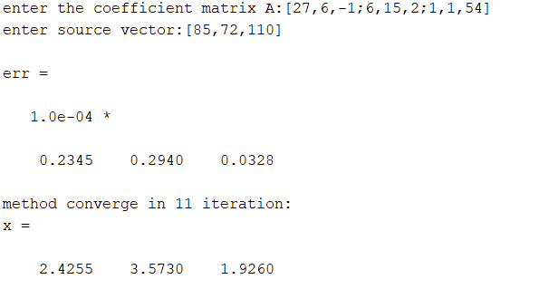

**2.Gauss Seidel Method**

**CODE**

clc

clear all

A= input('enter the coefficient matrix A:');

B= input('enter source vector:');

maxerr=1e-5;

x=zeros(1,size(A,1));

n=size(A,1);

err=Inf;

itr=0;

while all(err>maxerr)

xold=x;

for i=1:n

sum=0;

for j=1:i-1

sum = sum +A(i,j)*x(j);

end

for j =i+1:n

sum = sum +A(i,j)*xold(j);

end

x(i)=(B(i)-sum)/A(i,i);

end

itr=itr+1;

y(itr,:)=x;

err=abs(xold-x);

end

err

fprintf('method converges in %d iteration.',itr);

x

**OUTPUT**

